# Experiment 7

FS19CO042

**Title**: Write SQL code for creating of View. Perform Insert ,Modify, Delete records through view, Delete the View.

Working with Nested -Query.

**Theory:**

1. Simple View

➔ Simple View in SQL is the view created by involving only single table. In other words we can say that there is only one base table in case of Simple View in SQL

## Syntax : CREATE VIEW view-name AS

**SELECT column-name FROM table-name WHERE condition**

**Example : CREATE VIEW Brazil_Customers AS**

**SELECT CustomerName, ContactName FROM Customers**

**WHERE Country = 'Brazil';**

1. Complex view

➔ On other hand, Complex View is created by involving more than one table i.e., multiple tables get projected in Complex view.

## Syntax : CREATE VIEW view-name AS

**SELECT column-name FROM table-name JOIN aggregate-function**

**GROUP BY column-name**

**Example : CREATE VIEW dept_income AS**

**SELECT d.Name as DepartmentName, sum(e.salary) as TotalSalary**

**FROM Employees e**

**JOIN Departments d on e.DepartmentId = d.id GROUP BY d.Name**

1. INSERT query syntax and example.

➔ *INSERT* command is used to insert data into the row of a table.

## Syntax : INSERT INTO TABLE_NAME (col1, col2, col3, col N) VALUES (value1, value2, value3, valueN);

**Example : INSERT INTO fyfs (name, roll) VALUES ("Rupesh", "FS43");**

1. UPDATE query syntax and example**.**

➔ *UPDATE* command is used to update or modify the value of a column in the table.

## Syntax : UPDATE table_name SET [column_name1=value1] [WHERE CONDITION]

**Example : UPDATE students SET User_Name = “Rupesh” WHERE Student_Id = '43'**

1. DELETE query syntax and example**.**

➔ *DELETE* is used to remove one or more row from a table. **Syntax : DELETE FROM table_name [WHERE condition]; Example : DELETE FROM javatpoint WHERE Author="Rupesh";**

1. DROP VIEW

➔ *DROP VIEW* command is used to delete the view

**Syntax : DROP VIEW *view_name***

## Example : DROP VIEW [Brazil Customers]

1. NESTED QUERY

➔ Query written inside a query is called as SQL Nested Query

## Syntax : SELECT Column1,Column2… From Table_Name

**WHERE Column_Name Operator(Select Column1,Column From Table_Name_2)**

**Operator (Select Column1,Column2…..From Table_Name_3)**

**Example : *SELECT Model FROM Product***

***WHERE ManufacturerID IN (SELECT ManufacturerID***

***FROM***

***Manufacturer***

***WHERE Manufacturer = 'Dell')***

Outputs:

Initial tables setup:

Students table: academicSubjects table:

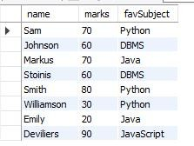 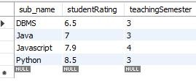

Creating Simple view:

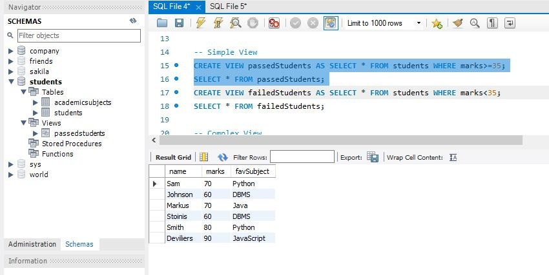

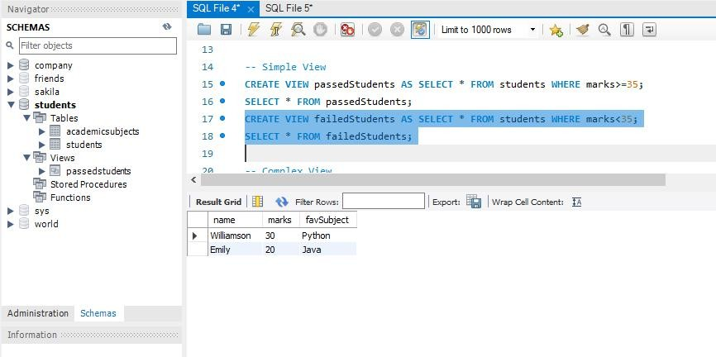

Creating complex view:

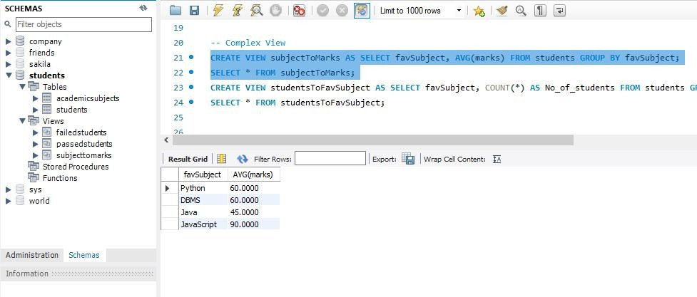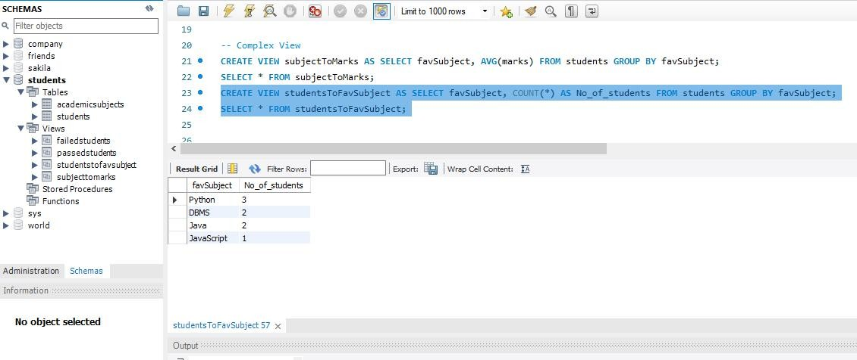

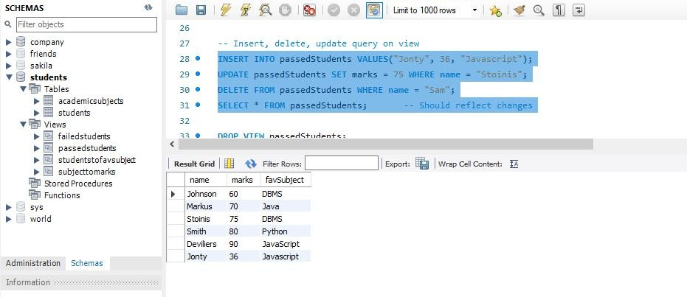Insert delete and update on view:

Drop view:

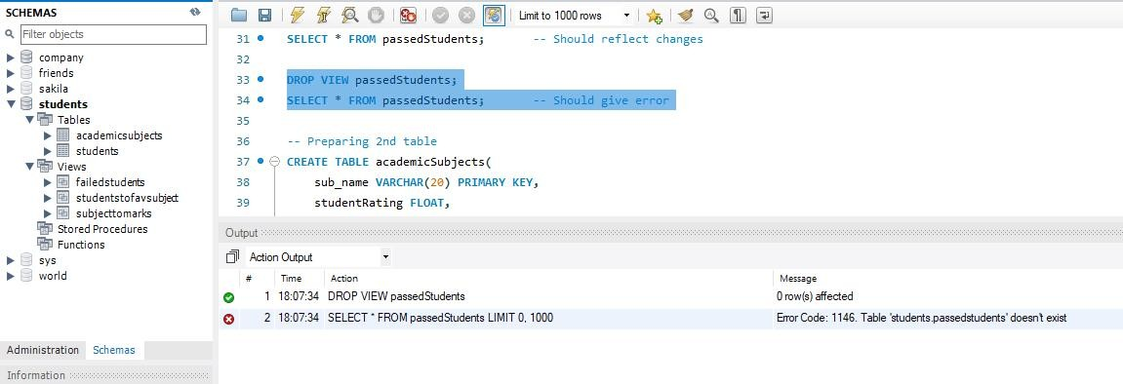

Nested query on single table:

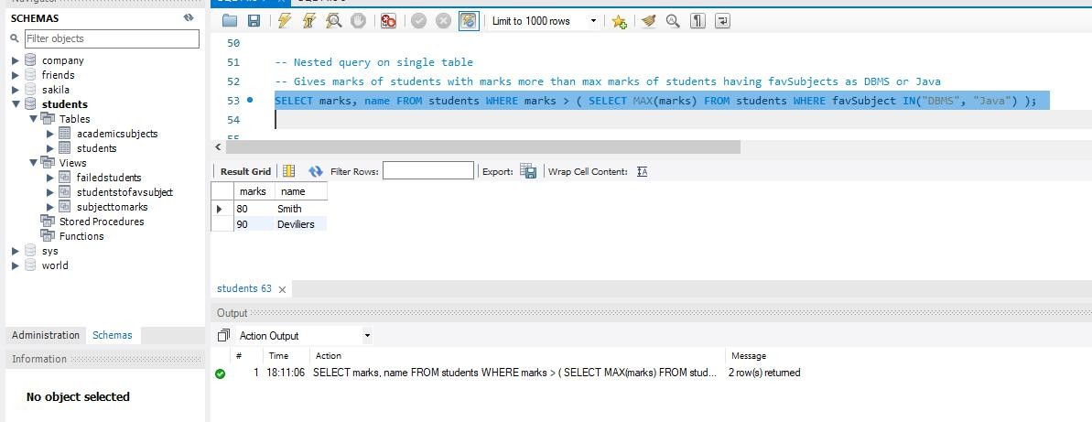

Nested query using two tables:

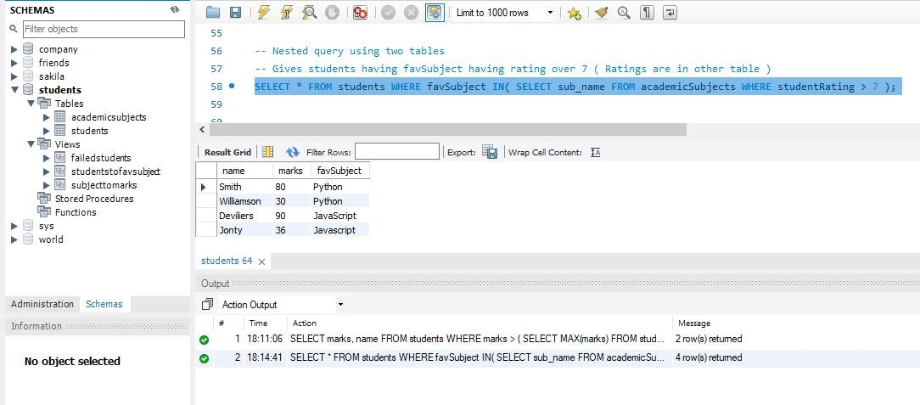

Conclusion: Thus, we created, modified(Inserted updated deleted) and deleted views